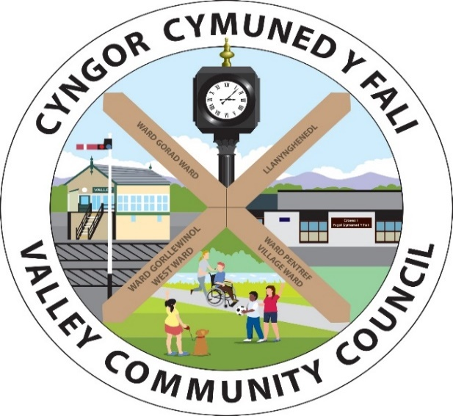

Clerc/Clerk: Rhianwen Sheldon
Cyfeiriad/
Address: 27 Alltwen, Llysfaen, Colwyn Bay, LL29 8PG
Ffon/Tel: 07786253828
Ebost/Email: valleycommunitycouncil@gmail.com
Safle We: http://www.cyngor-cymuned-fali.cymru
Website: http://www.valley-community-council.wales

Agenda Cyfarfod Pwyllgor Parciau / Agenda of Parks Committee
07/08/2024 - 7.00 yh/pm
Lleoliad/Location: Parc Mwd

 | Croeso | Welcome
 | Presennol/Ymddiheuriadau | Present/Apologies
 | Cyllideb a Gwariant 2024/25 | Budget and Expenditure 2024/25
 | Parc Mwd | Parc Mwd
4.1 | Leoedd Lleol ar gyfer Natur – Grant Enfawr | Local Places for Nature - Supersize Grant
4.2 | Mannau Gwyrdd – Datblygu’r Triongl | Green Spaces – Triangle development
4.3 | Cwrt Pelfasged | Basketball Court
4.4 | Rampiau atal cyflymder | Speed Bumps
4.5 | Cynwysyddion Storio CPD Y Fali | Valley FC Storage Containers
4.6 | Baneri Nawdd CPD Y Fali | Valley FC Sponsorship Banners
4.7 | Baw Cwn | Dog Fouling
 | Maes chwarae ger yr ysgol | Play area by the school
 | Safleoedd Bws | Bus Shelters
 | Asedau eraill | Other Assets
 | Arolygon iechyd a diogelwch | Health and safety inspections
 | Unrhyw fater arall | Any other business

