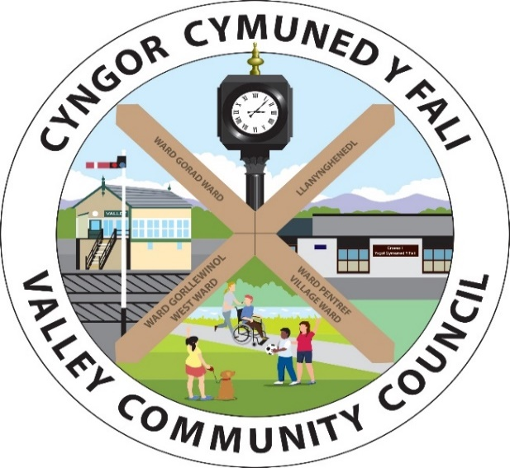

Clerc/Clerk: Rhianwen Sheldon
Cyfeiriad/
Address: 27 Alltwen, Llysfaen, Colwyn Bay, LL29 8PG
Ffon/Tel: 07786253828
Ebost/Email: valleycommunitycouncil@gmail.com
Safle We: http://www.cyngor-cymuned-fali.cymru
Website: http://www.valley-community-council.wales

Agenda Cyfarfod Pwyllgor Parciau / Agenda of Parks Committee Meeting
14/1/25 - 7.00 yh/pm
Lleoliad/Location: ZOOM
https://us06web.zoom.us/j/88554614806?pwd=apIryKVqciN2IRxwVVRkSG6gS8Gvvo.1

 | Croeso | Welcome
 | Presennol/Ymddiheuriadau | Present/Apologies
 | Finance | Finance
 | Cynllun Gweithredu Trwsio a  Gwellianau a diweddariad rosiectau | Action Plan for Repairs & Improvements including project updates
 | Pafliwn a storfa | Pavillion & Storage
 | Diweddariad COD Y Fali | Valley FC update
 | Diweddariad Grwp Cymunedol Fali | Valley Community Group update
 | Arolygon iechyd a diogelwch | Health and safety inspections
 | Unrhyw fater arall | Any other business

